**1. Please draws and show orientation of a Straight-through cable for CAT 5 cables**.

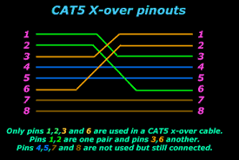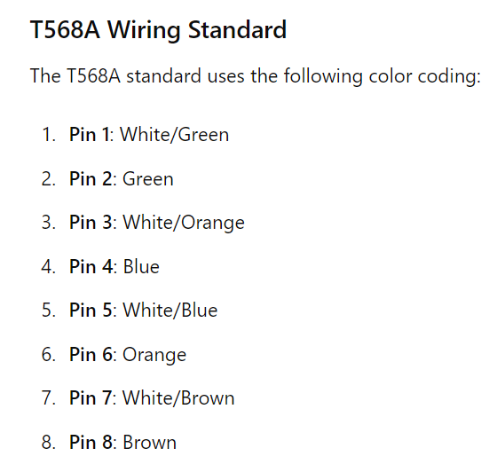

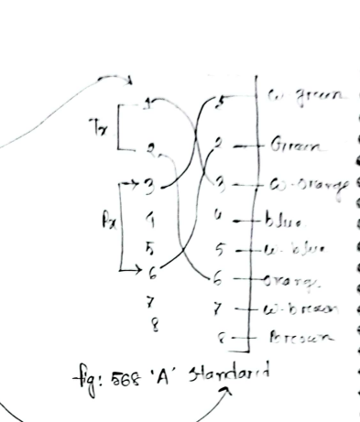

**2. What is the function of ARP protocol?**

Ans-The purpose of ARP is to resolve addresses by finding the MAC address that corresponds to an IP address. Even though a sending system may know the IP address it wants to ultimately send data to, it may not know the MAC address.

ARP is necessary because the software address (IP address) of the host or computer connected to the network needs to be translated to a hardware address (MAC address). Without ARP, a host would not be able to figure out the hardware address of another host.

**3. Data packets usually have a TTL that tells how long the packet will last; briefly explain why a clock is not possible to implement in the packet’s header to denote its age**.

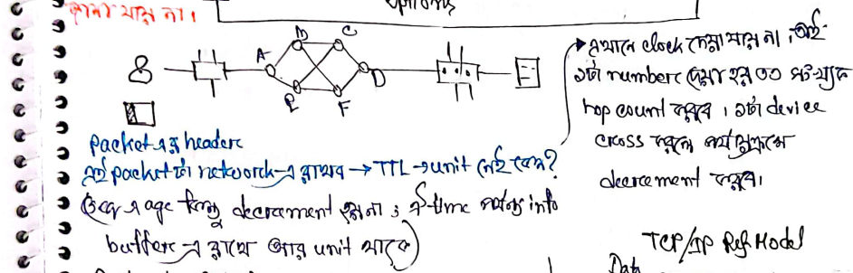

Using a clock to show a packet's age in its header is not practical because it’s too complicated to keep all network devices perfectly synchronized. Each device would need an accurate clock, and delays can vary as packets travel through different routers and switches, making it hard to track time accurately.

Instead, the Time-To-Live (TTL) field is used. TTL starts with a set value and decreases by one at each hop. When TTL reaches zero, the packet is discarded. This method is simple and effective, ensuring that packets don't circulate indefinitely without needing complex time synchronization.

**4. What is subnet mask in decimal notation for the any “B” class IP if 10 bits are taken to create subnets?**

Ans- The subnet mask for the sub netted "B" class IP address would then be calculated as follows:

* The first 16 bits remain unchanged, representing the network portion.
* The next 10 bits (which were borrowed to create subnets) are all set to 1, representing the subnet portion.
* The remaining 6 bits represent the host portion and are set to 0.

So, the subnet mask in decimal notation would be:

11111111.11111111.11000000.00000000

Which translates to:

255.255.192.0

**5. What is the ‘wild card’ mask’s IP if the subnet mask is 255.255.240.0?**

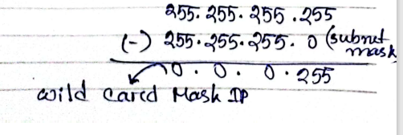

255.255.255.255

-255.255.240.0

0.0.15.255

**6. Why hosts generate ARP protocol when ping is performed with IPs?**

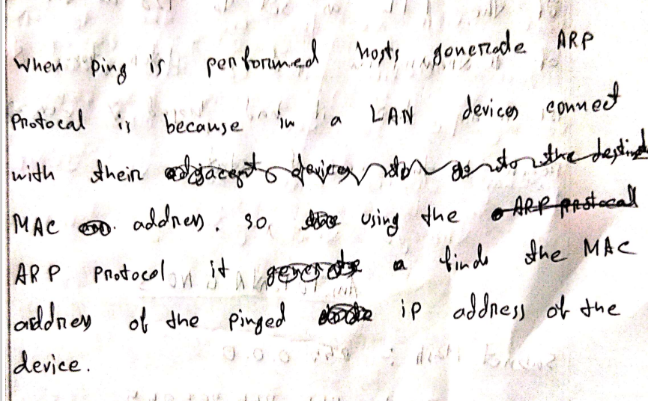

Ans- When you ping another device by its IP address, your computer needs to know its MAC address, which is like its physical address on the local network. So, it asks, "Who has this IP address? Tell me your MAC address." This asking is done using a protocol called ARP.

Once it gets the MAC address, it's like knowing the recipient's exact location. Then, your computer can send the ping message directly to that device. So, ARP helps your computer find the MAC address of the device it wants to ping, allowing the ping message to reach its destination correctly.

**Alternative ans-**

When a host performs a ping operation using an IP address, it needs to resolve the IP address to the corresponding MAC address in order to send the ICMP echo request packets. The Address Resolution Protocol (ARP) is used for this purpose.

Here's why hosts generate ARP protocol requests when ping is performed with IPs:

1. **IP to MAC Address Resolution**:
   * In Ethernet networks, communication occurs at the Data Link Layer using MAC addresses. When a host wants to communicate with another host on the same local network using its IP address, it needs to know the MAC address of the destination host to frame the Ethernet packets properly.
   * Ping uses the Internet Control Message Protocol (ICMP) to send echo request packets to the destination IP address. Before sending these packets, the source host needs to know the MAC address of the destination host.
2. **ARP Request**:
   * When a host wants to ping another host using its IP address, it first checks its ARP cache (a table of IP-to-MAC address mappings). If the MAC address corresponding to the destination IP address is not found in the ARP cache, the source host generates an ARP request packet.
   * The ARP request packet is broadcasted on the local network, asking "Who has IP address X? Please tell me your MAC address."
3. **ARP Reply**:
   * The host with the matching IP address (the destination host) replies to the ARP request with an ARP reply packet. This packet contains the MAC address corresponding to the IP address queried in the ARP request.
   * The source host receives this ARP reply and updates its ARP cache with the IP-to-MAC address mapping of the destination host.
4. **Sending ICMP Echo Request**:
   * With the MAC address of the destination host obtained from the ARP reply, the source host can now properly frame the ICMP echo request packets and send them to the destination host.

In summary, when a host performs a ping operation using an IP address, ARP protocol requests are generated to resolve the IP address to the corresponding MAC address of the destination host, enabling proper communication at the Data Link Layer in Ethernet networks.

**7. What does it mean if TTL is found to be 121, whereas it is set 128 at the time of transmission?**

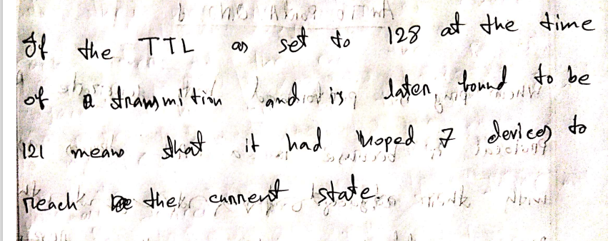

When a packet is sent across a network, it includes a Time-To-Live (TTL) value, which represents the maximum number of network hops (routers or switches) the packet can pass through before being discarded.

If a packet's TTL is initially set to 128 when it's sent, but it's observed to have a TTL of 121 when received, it indicates that the packet has passed through 7 network hops during its journey.

Each time the packet passes through a network device, the TTL is decremented by one. So, if the TTL decreases from 128 to 121, it means the packet has crossed 7 devices in the network.

Understanding the TTL value of packets helps in monitoring network health, detecting potential network issues, and ensuring packets reach their intended destinations within the expected number of hops.

**8. What is the subnet mask and wild card mask in decimal notation for the any “A” class IP if 12 bits are taken to create subnets?**

Ans- To find the subnet mask and wildcard mask for an "A" class IP address when 12 bits are used for subnetting, let's first understand how subnetting works.

For an "A" class IP address, the default subnet mask is 255.0.0.0 in decimal notation. This means that the first 8 bits are reserved for the network portion, and the remaining 24 bits are for the host portion.

When subnetting, we borrow some of the bits from the host portion to create subnets. In this case, we are borrowing 12 bits, leaving 12 bits for hosts in each subnet.

So, the subnet mask for this subnetted network would be:

11111111.11110000.00000000.00000000

255.240.0.0 in decimal notation

To find the wildcard mask, you simply subtract each octet of the subnet mask from 255:

Wildcard mask:

00001111.11110000.11111111.11111111

255.15.255.255 in decimal notation

9. 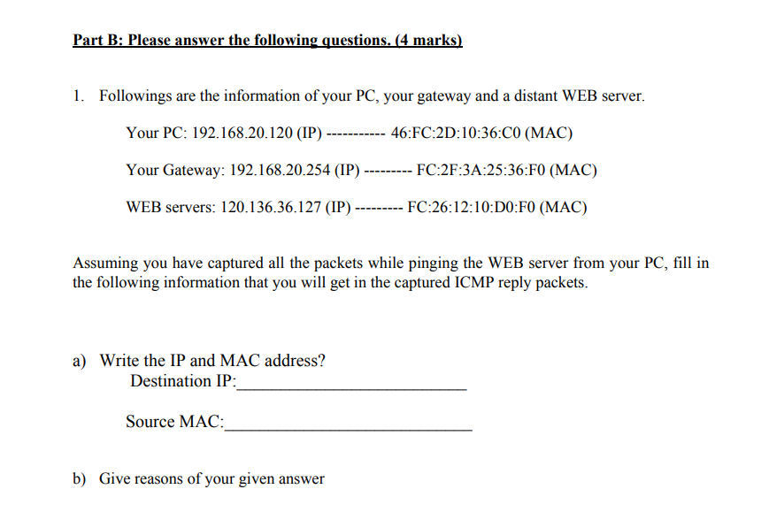

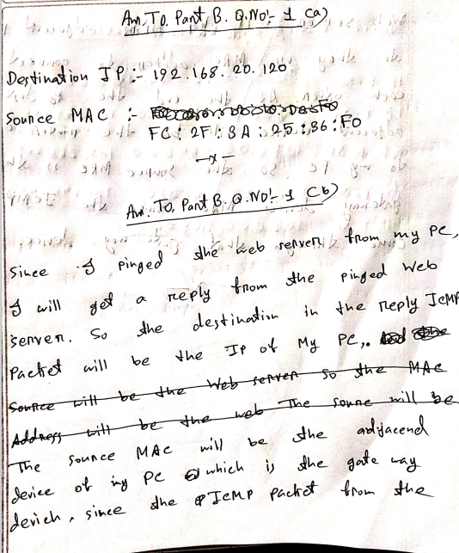 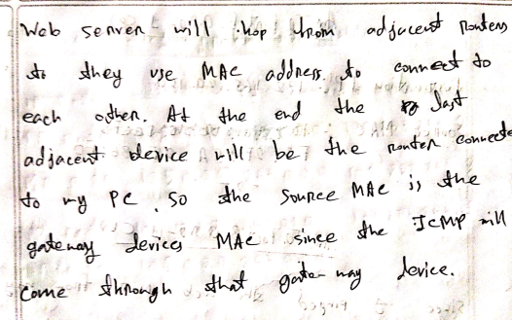

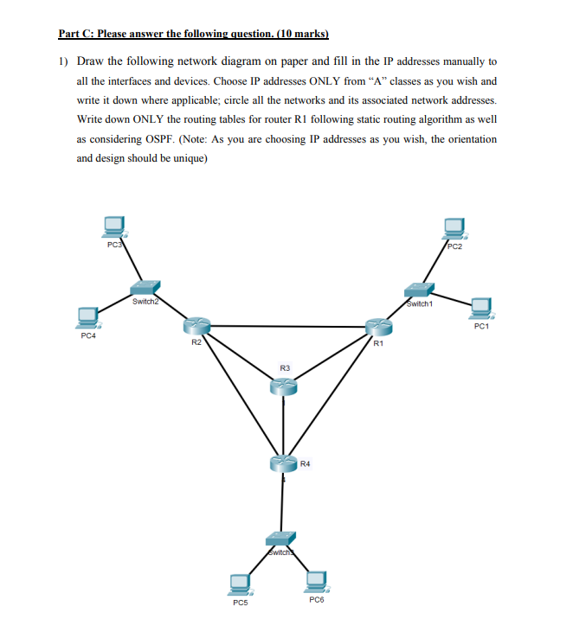 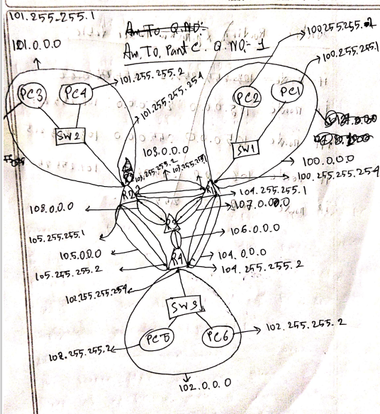 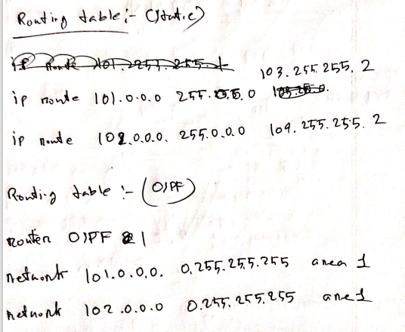

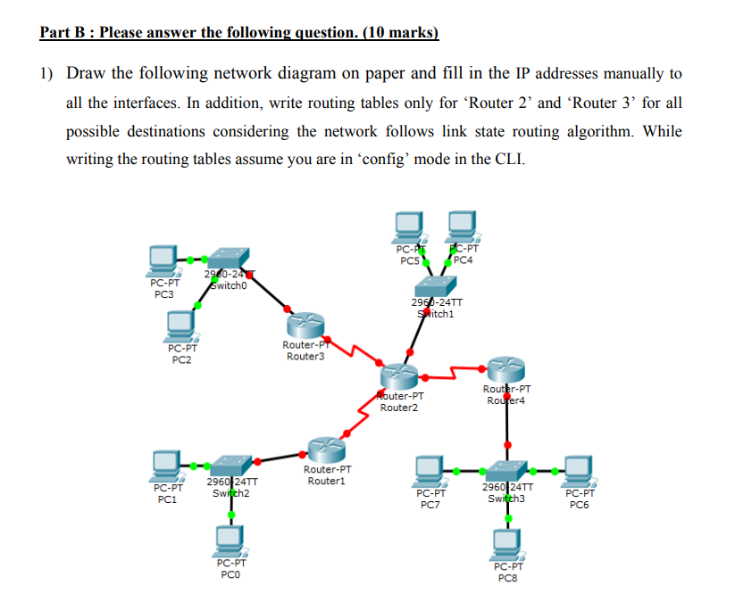

192.168.30.0

192.168.40.0

192.168.10,0

192.168.20.0

